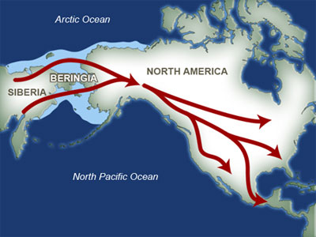About 12000 years ago, Alaska was probably the place to be as far as the Americas were concerned. The land bridge through what is now the Bering Strait fed early settlers into the Western hemisphere. These migrant’s progeny (over many generations) would become native Americans. This seems to be verified by DNA tests that somewhat prove significant linkages between native Americans and the present Asian population.

The land bridge was probably a result of an ice age that had taken hold perhaps a century before. The resultant freezing of water lowered the average Pacific ocean depth such that Beringia (shown right) allowed the connection between the two hemispheres.

Just as an ice age led to connections, the subsequent warming led to ice melt and a rising of the water depth to the point that the land bridge was broken.

This caused a dramatic change in Alaskan activity as this migration severed. In addition, the separation between the Pacific (shorn of its northern appendage) and the now newly created Arctic Ocean would certainly have affected the weather in the area. Instead of being the center of activity, Alaska became a cold, remote outpost in the Western Hemisphere. A few centuries would need to elapse before Alaska again became of interest.

The 1700’s saw exploration by the French and British of what is today Canada (east of Alaska) while Alaska was visited by Russians interested in the fur trade and, it is said, the exploitation of the native peoples. Keep in mind that shortly thereafter Russia and England would become enemies with several clashes in Iraq and the Crimea.

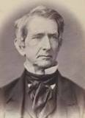This brings about a significant change in Alaska’s status after our country’s civil war in the 1860’s. The Russian Tsar, needing both funding and an escape from British pressure (of a pincer movement involving western Canada and Southern Russia) poses the following to the post-civil war American government: Perhaps the United States would like to buy the Russian interest in Alaska.

William Seward (shown here), a challenger to Lincoln for the Republican presidential nomination of 1860, a one-time governor and senator from New York and the Secretary of State in the post Lincoln administration, snaps up the territory for 7.2 million dollars which at that time was a considerable sum. So little was known about Alaska, and so little respect afforded this remote land, that for many years the area (and its purchase) was known as Seward’s folly.

The American planting of the flag with the purchase of the Alaskan territory does not resolve its problems by any means. The question of the boundary of what would become the forty nineth state remained just as problematic with the new governance and the official boundary would not be resolved unto the 1920’s with agreement between the United States, England and Canada. For some thirty five years, few immigrants – this time from what would become known as the lower 48 states – made their way north into the territory.

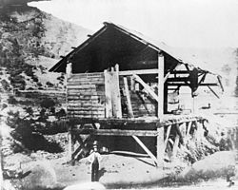Eventually the same reason for the populating of California and Western Canada would create an influx of emigration into the Alaskan territory: gold. For example, the sleepy California of Zorro and Don Diego de la Vega fame was transformed with the striking of gold at Sutton Mill(right) in 1848. When news of the strike spread across the pacific, it was the pacific populace that rushed into the California territory. It would take time for the eastern populace of the United States to join the rush because in 1848 the only way to travel and transmit news was ships around Chile’s Cape Horn and then onto the Eastern US, a much longer trip than even travelling back and forth to Australia or China in those days.

The ratio of population growth in the pursuit of gold and fortune was considered so great in that instance that only 3 years later California would petition and be granted statehood. Some historians claim that California statehood was one of the causes of the civil war some 10 years hence: if so that somewhat small population movement as we would look at it using today’s standard had great effect.

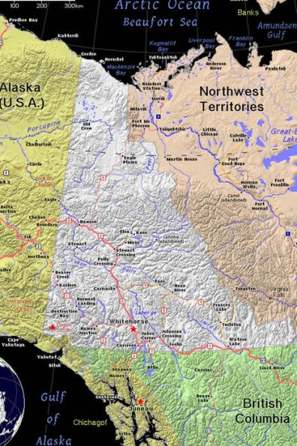In the middle 1890’s a similar situation occurred in the Yukon, known as the Yukon gold rush. Close to the Alaskan border, about halfway between Juneau and the Arctic Ocean’s Beaufort Sea, the Klondyke river would be the scene of gold prospecting. It is said that 100000 prospective miners flooded the area. One assumes that advances in transportation and media technologies allowed for a faster migration than what occurred in California some 40 years earlier. Another assumption is that this migration was focused more on North Americans and less on Pacific populations.

This popularity of Klondyke gold must have made tremendous changes in the concept of the Canadian Yukon territory. Even the question of whether the Yukon should be administered by Canada would have been answered. Far northern Canadian locations are defined by where the waters of the territory drain. The Northwest territories (and the subsequent addition of Nunavut) are required to drain into Hudson Bay

But the Yukon drains into the Pacific. One assumes pre Klondyke that Canada was indifferent in the question of governing this area due to cost. But post gold rush, with the possibilities of taxing gold profits, the Yukon was looked on much differently.

And that takes us to the Nome gold rush of 1899 through 1909, an event that transformed the town of Nome (and its environment). For the entire territory of Alaska, this was the main event subsequent to Seward’s purchase.

Finding gold in this gold rush required no mining skills and little other skills except for the ability to survive climate conditions in that area. The gold could be found on the beaches around the city and, with Nome being a port city, it was easier to get to than the previous rushes.

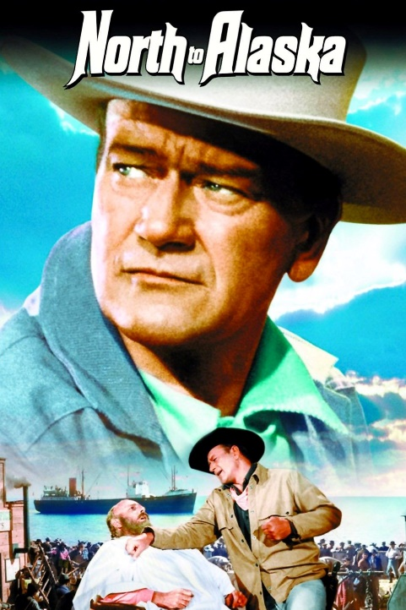We have mentioned these gold rushes (and especially the Nome gold rush) as it is the basis of the Germantown Sunday morning session teach of January 27, 2018. If you attended the session you already have been told that Od Nashuv is an Israeli renditon of the theme song of the 1960’s movie “North To Alaska”. To the right is a poster for this movie.

The movie was made and appeared at another significant time event in the history of the Alaskan terriotory – somewhat after the proclamation on Jan 3, 1959 making Alaska the 49th state. 1959 would also see Hawaii join the union some time later that year as the 50th state.

With two new states in the United States, all things Hawaiian and Alaskan became vogue. Just look at men’s fashion, especially Hawaiian shirts, in the early 60’s. Note the increase in the popularity of Jack London and Robert Service’s books. In fact, this popularity in fiction caused an increase in film scripts about Alaska, especially about the various gold rushs.

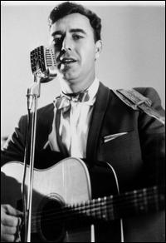One such script was the aforementioned North To Alaska starring John Wayne, [Stewart Granger](https://www.fandango.com/people/Stewart-Granger-254896/overview) and Capucine. Wayne was a movie idol at the time (although his career had somewhat reached a peak by 1960) and had made his mark during the 1940,1950s doing World War II and western movies. In such genres he was rarely cast in a romantic role but North To Alaska would have him play against form. This movie is also interesting to Philadelphians as one of this movies costars is Ernie Kovacs, one of the most inventive 1950’s TV comedians who tragically died in an automobile accident in 1962 and was a native of the Delaware Valley.

The screenwriters of North To Alaska - [John Lee Mahin](https://www.bing.com/search?q=john+lee+mahin&filters=ufn%3a%22john+lee+mahin%22+sid%3a%222ee311ae-7475-9de2-599f-1e5602dba661%22+catguid%3a%22338b8727-aa35-e7c2-1745-6f936800cd43_d2499163%22+segment%3a%22generic.carousel%22&FORM=SNAPST), [Martin Rackin](https://www.bing.com/search?q=martin+rackin&filters=ufn%3a%22martin+rackin%22+sid%3a%228adacb39-ff07-68a6-0070-94686c375498%22+catguid%3a%22338b8727-aa35-e7c2-1745-6f936800cd43_d2499163%22+segment%3a%22generic.carousel%22&FORM=SNAPST) and [Claude Binyon](https://www.bing.com/search?q=claude+binyon&filters=ufn%3a%22claude+binyon%22+sid%3a%220b972139-878d-fafc-b645-7b8dd6786a50%22+catguid%3a%22338b8727-aa35-e7c2-1745-6f936800cd43_d2499163%22+segment%3a%22generic.carousel%22&FORM=SNAPST) - used the 1939 play “Birthday Gift” by the Hungarian born writer Ladislas Fodor as the basis of the story. The plot involves two brothers and a partner striking it rich in 1901 during the Nome gold rush. One brother uses part of his money to pay for a mail order bride but things go wrong when the partner of the brothers goes to collect the bride in Seattle. The mixup is the major plot point of the movie. The movie is released to the general public in November 1960.

For the teach on January 27th, more interest was put into the movie’s theme song. The music is credited to Lionel Newman with the lyrics being written by Mike Phillips. However, the big aspect of this is the singer, Johnny Horton (right), who that year seemed to be creating a new genre of music, a kind of historic country and western. Earlier in 1960 Horton had released a single “Sink The Bismarck” about the Atlantic battle between England and Germany during World War II, and the previous year had covered “The battle Of New Orleans” which was tremendously popular and repeatedly played on almost every music radio station at the time.

Of more interest, 1959 had also seen his release of “When It's Springtime in Alaska". Perhaps this was the reason for the producers selecting Horton to sing the North to Alaska theme song.

The North By Alaska movie theme would hit #4 in the pop charts during 1961 and was for a time during ‘61 the most popular country and western song in the nation. Unfortunately, Horton would never see the success of this as he died in a tragic automobile accident late in 1960 at the age of 35.